Warning # 849 in column 23. Text: en_CM
The LOCALE subcommand of the SET command has an invalid parameter. It could
not be mapped to a valid backend locale.
GET
FILE='C:\Users\h\Downloads\Adolescents behavior 5.sav.sav'.
DATASET NAME DataSet1 WINDOW=FRONT.
ROC No.of.absences No.of.family.members BY Disciplinary.violations (1)
/PLOT=CURVE(REFERENCE)
/PRINT=SE COORDINATES
/CRITERIA=CUTOFF(INCLUDE) TESTPOS(LARGE) DISTRIBUTION(FREE) CI(95)
/MISSING=EXCLUDE.

ROC Curve

Notes
Output Created |  | 15-JAN-2023 04:00:28
Comments
Input | Data | C:\Users\h\Downloads\Adolescents behavior 5.sav.sav
Input | Active Dataset | DataSet1
Input | Filter | <none>
Input | Weight | <none>
Input | Split File | <none>
Input | N of Rows in Working Data File | 2252
Missing Value Handling | Definition of Missing | User-defined missing values are treated as missing.
Missing Value Handling | Cases Used | Statistics are based on all cases with valid data for all variables in the analysis.
Syntax |  | ROC No.of.absences No.of.family.members BY Disciplinary.violations (1)  /PLOT=CURVE(REFERENCE)  /PRINT=SE COORDINATES  /CRITERIA=CUTOFF(INCLUDE) TESTPOS(LARGE) DISTRIBUTION(FREE) CI(95)  /MISSING=EXCLUDE.
Resources | Processor Time | 00:00:03.31
Resources | Elapsed Time | 00:00:01.14

[DataSet1] C:\Users\h\Downloads\Adolescents behavior 5.sav.sav

Case Processing Summary
Disciplinary.violations | Valid N (listwise)
Positiveª | 75
Negative | 1965
Missing | 212

Larger values of the test result variable(s) indicate stronger evidence for a positive actual state.
a. The positive actual state is yes.

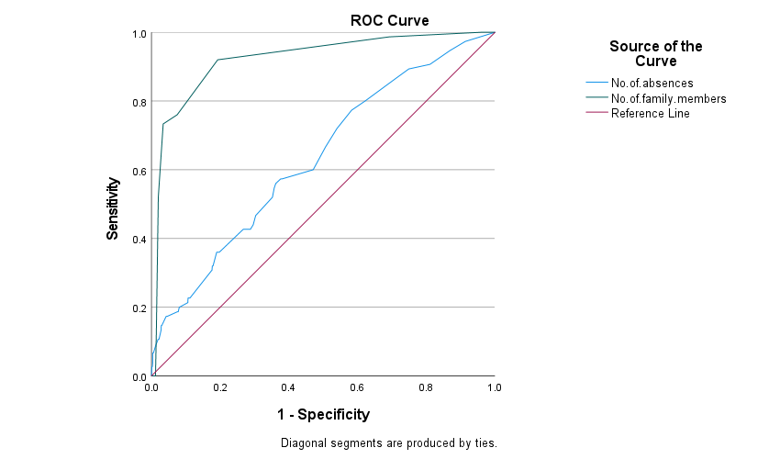

Area Under the Curve
Test Result Variable(s) | Area | Std. Errorª | Asymptotic Sig.^{b} | Asymptotic 95% Confidence Interval
 |  |  |  | Lower Bound | Upper Bound
No.of.absences | .633 | .033 | .000 | .569 | .696
No.of.family.members | .923 | .017 | .000 | .889 | .956

The test result variable(s): No.of.absences, No.of.family.members has at least one tie between the positive actual state group and the negative actual state group. Statistics may be biased.
a. Under the nonparametric assumption
b. Null hypothesis: true area = 0.5

Coordinates of the Curve
Test Result Variable(s) | Positive if Greater Than or Equal Toª | Sensitivity | 1 - Specificity
No.of.absences | -1.00 | 1.000 | 1.000
No.of.absences | .50 | .973 | .913
No.of.absences | 1.50 | .947 | .869
No.of.absences | 2.50 | .907 | .811
No.of.absences | 3.50 | .893 | .749
No.of.absences | 4.50 | .867 | .712
No.of.absences | 5.50 | .800 | .622
No.of.absences | 6.50 | .773 | .583
No.of.absences | 7.50 | .720 | .540
No.of.absences | 8.50 | .667 | .507
No.of.absences | 9.50 | .600 | .471
No.of.absences | 10.50 | .573 | .380
No.of.absences | 11.50 | .573 | .376
No.of.absences | 12.50 | .560 | .362
No.of.absences | 13.50 | .547 | .357
No.of.absences | 14.50 | .520 | .352
No.of.absences | 15.50 | .467 | .303
No.of.absences | 16.50 | .440 | .296
No.of.absences | 17.50 | .427 | .288
No.of.absences | 18.50 | .427 | .275
No.of.absences | 19.50 | .427 | .267
No.of.absences | 20.50 | .360 | .197
No.of.absences | 21.50 | .360 | .197
No.of.absences | 22.50 | .360 | .193
No.of.absences | 23.50 | .360 | .192
No.of.absences | 24.50 | .360 | .190
No.of.absences | 25.50 | .320 | .179
No.of.absences | 26.50 | .320 | .178
No.of.absences | 27.50 | .320 | .177
No.of.absences | 28.50 | .307 | .176
No.of.absences | 29.50 | .307 | .175
No.of.absences | 30.50 | .227 | .112
No.of.absences | 33.00 | .227 | .111
No.of.absences | 35.50 | .227 | .107
No.of.absences | 37.00 | .227 | .106
No.of.absences | 39.00 | .213 | .106
No.of.absences | 41.00 | .200 | .081
No.of.absences | 43.50 | .200 | .081
No.of.absences | 45.50 | .187 | .078
No.of.absences | 46.50 | .187 | .077
No.of.absences | 47.50 | .187 | .076
No.of.absences | 48.50 | .187 | .076
No.of.absences | 49.50 | .187 | .075
No.of.absences | 51.00 | .173 | .046
No.of.absences | 52.50 | .173 | .045
No.of.absences | 54.00 | .173 | .045
No.of.absences | 55.50 | .173 | .044
No.of.absences | 56.50 | .173 | .043
No.of.absences | 58.50 | .173 | .043
No.of.absences | 61.00 | .147 | .030
No.of.absences | 63.50 | .147 | .030
No.of.absences | 67.00 | .147 | .028
No.of.absences | 69.50 | .133 | .028
No.of.absences | 71.50 | .107 | .022
No.of.absences | 73.50 | .107 | .021
No.of.absences | 74.50 | .107 | .021
No.of.absences | 76.00 | .107 | .020
No.of.absences | 78.50 | .107 | .019
No.of.absences | 89.50 | .093 | .014
No.of.absences | 99.50 | .093 | .014
No.of.absences | 101.00 | .067 | .006
No.of.absences | 111.00 | .067 | .005
No.of.absences | 125.00 | .067 | .005
No.of.absences | 134.00 | .067 | .004
No.of.absences | 138.50 | .053 | .004
No.of.absences | 144.50 | .040 | .004
No.of.absences | 157.50 | .027 | .003
No.of.absences | 172.50 | .027 | .002
No.of.absences | 185.00 | .027 | .002
No.of.absences | 195.00 | .027 | .001
No.of.absences | 201.00 | .000 | .000
No.of.family.members | 1.00 | 1.000 | 1.000
No.of.family.members | 2.50 | 1.000 | .958
No.of.family.members | 3.50 | .987 | .692
No.of.family.members | 4.50 | .920 | .193
No.of.family.members | 5.50 | .760 | .075
No.of.family.members | 6.50 | .733 | .034
No.of.family.members | 7.50 | .520 | .020
No.of.family.members | 8.50 | .133 | .014
No.of.family.members | 9.50 | .000 | .012
No.of.family.members | 10.50 | .000 | .011
No.of.family.members | 11.50 | .000 | .007
No.of.family.members | 12.50 | .000 | .005
No.of.family.members | 14.00 | .000 | .002
No.of.family.members | 15.50 | .000 | .001
No.of.family.members | 17.50 | .000 | .001
No.of.family.members | 20.00 | .000 | .000

The test result variable(s): No.of.absences, No.of.family.members has at least one tie between the positive actual state group and the negative actual state group.
a. The smallest cutoff value is the minimum observed test value minus 1, and the largest cutoff value is the maximum observed test value plus 1. All the other cutoff values are the averages of two consecutive ordered observed test values.

